# Business travel

# Stop) CNN related news about xxx

# Ref:

1. Travel.docx in C:\Tracy\TW related\English\EF\2 EF oral topics - Script based on Level\EF L17_FieldSpecific\Travel English
2. The hotel/hospitality industry ` Industry_Hospitalityservice.docx` in C:\Tracy\TW related\English\EF\2 EF oral topics - Script based on Level\EF L17_FieldSpecific\Industry English

## Stop) Lexical resource

|  |
| --- |
| On that note = Speaking of which,  Speaking of sth, xx |
|  |
| let me get this straight 让我把这个搞清楚 让我把这件事情弄清楚  Straighten up your desk, rearranging pencils may not be a form of procrastination.  有时，清理一下你的桌子，重新整理一下你的笔什么的，并不会延误你的工作。 |
| Hotel amenities 酒店的服务设施 |
| Indirect objects间接宾语 an **object** of a verb that refers to the person that something is given to, said to, made for etc. For example, in the sentence ‘I asked him a question’, the indirect object is ‘him’.  间接宾语〔如I asked him a question中的him〕 |
|  |
| affirmative /əˈfɜːmətɪv/      |CET4 TEM4  1.  [ADJ](javascript:;)An affirmative word or gesture indicates that you agree with what someone has said or that the answer to a question is "yes." 肯定的 (言辞、手势)  •  Haig was desperately eager for an affirmative answer.   黑格极渴望得到一个肯定的回答。  2.  [ADJ](javascript:;)In grammar, an affirmative clause is positive and does not contain a negative word. (语法中) 肯定的 (分句)  3.  [PHRASE](javascript:;)If you reply to a question in the affirmative, you say "yes" or make a gesture that means "yes." (回答问题) 肯定地  •  He asked me if I was ready. I answered in the affirmative.   他问我是否准备好了。我肯定地回答了。 |

# Part 1)



You mean Lindstorm













No, no I can go there











## Dealing with information

|  |
| --- |
| When dealing with information, remember **'the three Cs'**: **clarifying**, **confirming** and **correcting** (clarifying, confirming and correcting). |

## Clarify and confirm information by using these expressions:

|  |  |  |
| --- | --- | --- |
|  | A: **You mean,** the CEO isn't cooperating with us? |  |
| B: Yes, **that's exactly what I mean.** |  |
|  |  |  |
|  |  |  |
|  |  |

|  |  |  |
| --- | --- | --- |
|  | A: **Let me make sure I've understood correctly.** They're not going to meet the deadline? |  |
| B: Yes, **that's correct.** |  |
|  |  |  |
|  |  |  |
|  |  |

|  |  |  |
| --- | --- | --- |
|  | A: **So, what you're saying is,** we've got a big problem on our hands. |  |
| B: **That's right.** |  |

**let me get this straight : 让我弄清楚**

## Correct information by using these expressions:

|  |  |  |
| --- | --- | --- |
|  | A: So, you want me to talk with the Product Optimization team? |  |
| B: **No. Actually,** I'm going to. |  |
|  |  |  |
|  |  |  |
|  |  |

|  |  |  |
| --- | --- | --- |
|  | A: So, we're looking for a new supplier? |  |
| B: **No, that's incorrect.** **In fact,** we're still trying to work with our old one. |  |

e.g.

LIZ: After the **buyout**, we'll have a 25% market share.    
ROB: **You mean ,** we're buying the company?  
LIZ: **Yes, that's exactly what I mean.** We're meeting with their CEO next week in New York.  
ROB: **Let me make sure that I've understood correctly** . We're buying the company, and you want me to go with you to a meeting next week?  
LIZ: **Yes, that's correct** . In New York.  
ROB: Wow. And we can talk about this? With staff, I mean.   
LIZ: **No. Actually ,** I'd like to wait until the deal is certain.

## Stressing words for emphasis and correction

|  |  |
| --- | --- |
|  | |
| When you are clarifying, confirming or correcting, you can add emphasis by stressing certain words. Notice that **yes** and **exactly** are stressed in this sentence: | |
|  |  |

|  |  |
| --- | --- |
|  | **Yes**, that's **exactly** what I mean. |
| Note that **actually** and **you're** are stressed in this sentence: | |
|  |  |

|  |  |
| --- | --- |
|  | No. **Actually**, **you're** going tomorrow. |
| You can change the meaning of a sentence by stressing different words. Notice how the meaning changes if **tomorrow** is stressed instead of **you're**. | |
|  |  |

|  |  |
| --- | --- |
|  | No. **Actually**, you're going **tomorrow**. |

## Reassuring

|  |  |  |
| --- | --- | --- |
| **Reassuring** | | |
| Use these expressions to find out if someone has a problem: | | |
|  |  |  |

|  |  |  |
| --- | --- | --- |
|  | *Is this a problem?* | Is this a problem? |
|  |  |  |

|  |  |  |
| --- | --- | --- |
|  | *Are you sure you can handle this?* | Are you sure you can handle this? |
|  |  |  |

|  |  |  |
| --- | --- | --- |
|  | *Are you OK with this?* | Are you OK with this? |
| Use these expressions to reassure someone: | | |
|  |  |  |

|  |  |  |
| --- | --- | --- |
|  | *No problem.* | No problem. |
|  |  |  |

|  |  |  |
| --- | --- | --- |
|  | *Don't worry. I can handle it.* | Don't worry. I can handle it. |
|  |  |  |

|  |  |  |
| --- | --- | --- |
|  | *It's going to be all right.* | It's going to be all right. |
|  |  |  |

|  |  |  |
| --- | --- | --- |
|  | *I'm sure it's all just a misunderstanding.* | I'm sure it's all just a misunderstanding. |

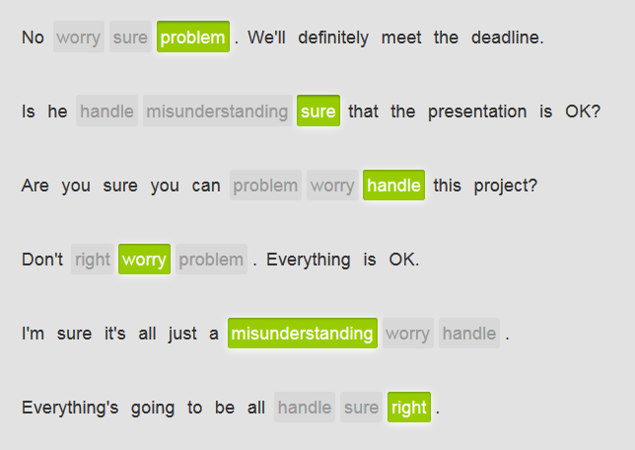

## Planning a business trip

A vendor for your company is behind schedule. Your colleague, Karen, was meant to go to their office, but something has come up and you are going instead. Reassure your boss that you can handle the situation.

# Part 2) Book a hotel

## Ref:

the hotel/hospitality industry ` Industry_Hospitalityservice.docx` in C:\Tracy\TW related\English\EF\2 EF oral topics - Script based on Level\EF L17_FieldSpecific\Industry English

## Book a hotel

Hello?



 Wonderful.









 mini-bar







 





  hmm, maybe I’ll begin

 you do? Wonderful.





 









## Hotel amenities 酒店的服务设施

What amenities does your hotel provide?

|  |
| --- |
| 极可意涡流式浴缸**whirlpool bathtub**，按摩浴缸Jacuzzi /dʒəˈkuːzɪ/    [N-COUNT](javascript:;)A Jacuzzi is a large circular bath fitted with a device that makes the water move around. “极可意”漩水浴缸; a large indoor **whirlpool bathtub** that makes hot water move in strong currents around your body jacuzzi /dʒəˈkuːzi/  a large bath/bathtub with a pump that moves the water around, giving a pleasant feeling to your body   1. Sitting in the jacuzzi helps me relax.   Listen to the audio  You can relax in the hotel spa and jacuzzi. |
| **mini-bar**  /ˈmɪnibɑːr/  a small fridge/refrigerator in a hotel room, with drinks in it for guests to use   1. The room had a well-stocked mini-bar with lots of snacks and drinks   Did you use anything from the mini-bar? |
| **airport transportation**  /ˈerpɔːrt trænspɔːrˈteɪʃn/  a vehicle, usually shared, which people can take to and from the airport   1. Is there airport transportation available over the holiday weekend? 2. convenient airport transportation   `airport transportation`  What transportation is there to the airport?  Do your hotel provide `airport transportation`? |
| Gym  golf course  The golf course and gym are free for hotel guests.  business center  We have a conference room and a business center.  Is there wireless internet in the rooms? |

## Intonation

|  |  |
| --- | --- |
| **Confirming: intonation and tag questions** | |
| You can ask for confirmation by repeating what someone just said. Notice the rising intonation. It signals that the woman is asking a question, and also helps communicate how she feels. | |
|  |  |
|  |

|  |  |
| --- | --- |
|  | A: *Does the hotel have a pool?* |
| B: *Yes, it's right next to the ocean.* |
| A: ***The pool's right next to the ocean?*** |
|  |  |
|  |

|  |  |
| --- | --- |
|  | A: *Could I have your passport number, please?* |
| B*:* ***My passport number?*** *Just a moment.* |

## Tag questions for asking for confirmation

|  |  |
| --- | --- |
| You can also use tag questions with **correct** or **right** to confirm or check information. If you know the answer, make your intonation flat instead of rising. | |
|  |  |

|  |  |
| --- | --- |
|  | *You're a five-star resort,* ***correct****?* |

|  |  |
| --- | --- |
| If you don't know the answer and are asking a real question, use a rising intonation with the tag. | |
|  |  |

|  |  |
| --- | --- |
|  | *The hotel has a bar and restaurant,* ***right****?* |
| Another way to ask for confirmation are tag questions like **You do?** and **You don't?** Notice again how these tags don't just signal a question but also communicate the speaker's feelings. | |
|  |  |
|  |

|  |  |
| --- | --- |
|  | A: *The hotel offers a free massage to all its guests.* |
| B:***You do?*** |
|  |  |
|  |

|  |  |
| --- | --- |
|  | A: *The hotel doesn't provide airport transportation.* |
| B:***You don't?*** |

## Respond in the affirmative

|  |
| --- |
| affirmative /əˈfɜːmətɪv/      |CET4 TEM4  1.  [ADJ](javascript:;)An affirmative word or gesture indicates that you agree with what someone has said or that the answer to a question is "yes." 肯定的 (言辞、手势)  •  Haig was desperately eager for an affirmative answer.   黑格极渴望得到一个肯定的回答。  2.  [ADJ](javascript:;)In grammar, an affirmative clause is positive and does not contain a negative word. (语法中) 肯定的 (分句)  3.  [PHRASE](javascript:;)If you reply to a question in the affirmative, you say "yes" or make a gesture that means "yes." (回答问题) 肯定地  •  He asked me if I was ready. I answered in the affirmative.   他问我是否准备好了。我肯定地回答了。 |

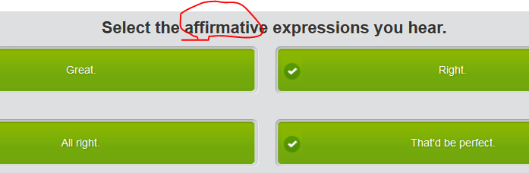

**HOTEL CLERK**: Hotel Royal. Good evening.  
BUSINESSMAN: Uh, hi. I have a reservation for the nights of December 7th and 8th. The name is Kent. Brad Kent.  
HOTEL CLERK: Uh-huh? Right . I see it here.  
BUSINESSMAN: I'd like to change that to the 8th and 9th, if possible.  
HOTEL CLERK: All right . Let me just check. No problem, sir.  I can make that change for you now, if you like.  
BUSINESSMAN: That'd be perfect . Thank you so much.

HOTEL CLERK: Not at all. Is there anything else?  
BUSINESSMAN: Uh, yes. Does my room have internet access?  
HOTEL CLERK: Yes, it does. Every room at Hotel Royal has free internet access.    
BUSINESSMAN: Great . Thank you very much.  
HOTEL CLERK: You're welcome. Goodbye.

# Part 3)Indirect objects间接宾语

an **object** of a verb that refers to the person that something is given to, said to, made for etc. For example, in the sentence ‘I asked him a question’, the indirect object is ‘him’.

间接宾语〔如I asked him a question中的him〕

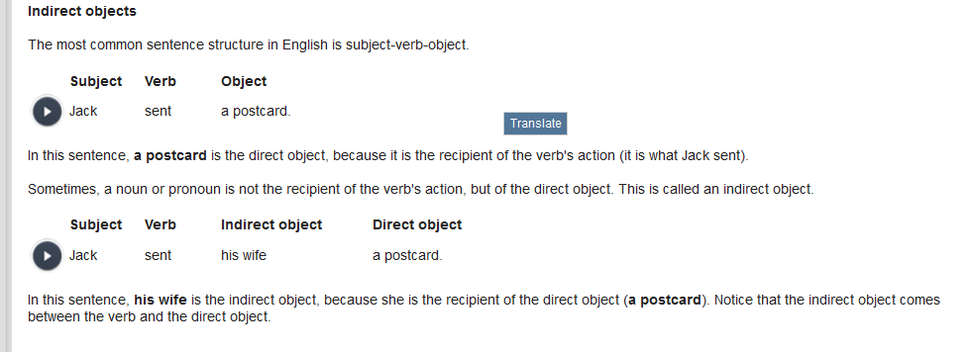

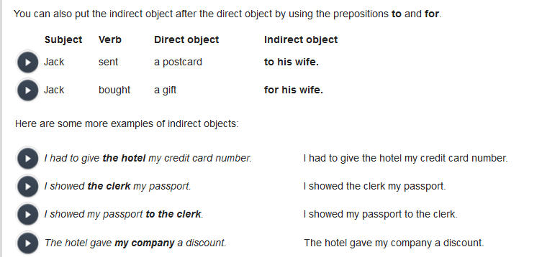

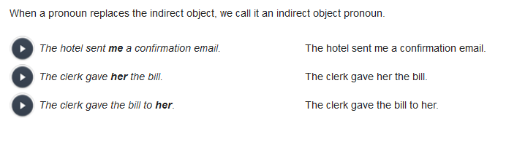

## Expressing urgency and importance

|  |  |  |
| --- | --- | --- |
|  | | |
| Use these expressions to express urgency: | | |
|  |  |  |

|  |  |  |
| --- | --- | --- |
|  | ***It's crucial*** *that we find a solution.* | It's crucial that we find a solution. |
|  |  |  |

|  |  |  |
| --- | --- | --- |
|  | ***It's urgent*** *the company find a buyer.* | It's urgent the company find a buyer. |
|  |  |  |

|  |  |  |
| --- | --- | --- |
|  | ***It's essential*** *that he attend the meeting.* | It's essential that he attend the meeting. |
|  |  |  |

|  |  |  |
| --- | --- | --- |
|  | ***It's vital*** *no one discuss this information.* | It's vital no one discuss this information. |
|  |  |  |

|  |  |  |
| --- | --- | --- |
|  | ***It's critical*** *that we meet the deadline.* | It's critical that we meet the deadline. |
|  |  |  |

|  |  |  |
| --- | --- | --- |
|  | ***It's imperative*** *all staff understand the situation.* | It's imperative all staff understand the situation. |

|  |  |  |
| --- | --- | --- |
| These fairly formal expressions are generally followed by the base form of the verb. Notice in the examples that there is no subject-verb agreement: The verbs **attend** and **report** don't end in **s**. After certain strong or emotional verbs like these, the second verb is in a special form, called the subjunctive. | | |
|  |  |  |

|  |  |  |
| --- | --- | --- |
|  | *It's essential that* ***he attend*** *the meeting.* | It's essential that he attend the meeting. |
|  |  |  |

|  |  |  |
| --- | --- | --- |
|  | *It's vital* ***she report*** *to us immediately.* | It's vital she report to us immediately. |
| Use the adverb **absolutely** to increase the sense of urgency: | | |
|  |  |  |

|  |  |  |
| --- | --- | --- |
|  | *It's* ***absolutely*** *critical that we meet the deadline.* | It's absolutely critical that we meet the deadline. |
|  |  |  |

|  |  |  |
| --- | --- | --- |
|  | *It's* ***absolutely*** *crucial we find a solution.* | It's absolutely crucial we find a solution. |
| Language note: Be careful how you use modifiers like **absolutely**, **completely** and **totally**; if the situation is not as urgent as your language suggests, you might be accused of exaggerating. | | |

Thank you all for coming today. First, let me say that **it is absolutely essential that** nothing I discuss here today go outside this room. That said, I think you all understand **how urgent it is that** we find a solution to the problem of our decreasing market share. **It's imperative that** we increase sales in the fastest-growing region for our products – Asia. Because of this, we have decided to purchase our biggest competitor. **It's vital that** this deal be successful. We have the financial strength, and **it's crucial that** we take advantage of this opportunity.

# Part 4 )